Name: Patrick Hewitt
Student ID: (removed for the public copy)
Date: September 25, 2026

Instructions: You should have one page (1 html file and 1 css file) of your site completed by the time you submit this. Use the following to have a written discussion about the current progress of your website. After answering the questions below, insert a screenshot of the index.html file's browser view that you have completed so far (remember, you should have one page’s browser view and a CSS file). Do NOT screenshot the HTML code, as we can’t run the code. Save the file to yourasurite – Project Assignment – Project Update 1.docx file and yourasurite – Project Assignment – Project Update 1.pdf file. Submit both files to Canvas.

- How do you feel your website is coming along? (10 points)
Better than I expected at this stage. The planning work is paying off: because I had already written the topic approval sheet and the planning and analysis sheet, I knew what the home page had to say before I opened a text editor, so building it was mostly layout rather than deciding what to put on it.

The home page is built and matches the wireframe I submitted last week. It has the header with the logo and site name, a five-link nav bar, a main area with a hero, a video section, three cards, a method section with a diagram and a list, and a closing call to action, plus a footer with site links, an external link to Yahoo Fantasy, an email link, and copyright. The external style sheet is doing all of the presentation work, so the HTML file has no style attributes in it.

What I am happy about is that the page reuses one structure I can copy to the other four pages, so How It Decides, FAQ, About, and Contact should be much faster to build than the first page was. What I still owe the project is content I have to capture rather than write: the fifteen-second screen recording of the advisor and a real annotated screenshot of the tool.

- What issues have you encountered on your first page? (4 points) How did you fix those issues, if you did? (3 points) Are there any issues still unresolved? (3 points)

Three real issues came up while building the first page.

First, my navigation links kept picking up the amber color I set for ordinary body links, so the nav looked like a row of paragraph links instead of a menu. I fixed it by writing a more specific nav a rule and adding a .current class for the page you are on. That was a useful lesson in how specificity actually works rather than how I assumed it worked.
Second, the section that pairs the diagram with the explanation text is a flex row, and at narrow widths the image and the text squeezed each other into unreadable columns. I fixed that with a media query at 700px that switches that section to block display and collapses the three cards to one column. This matters for my project because most of my audience arrives on a phone.
Third, I had color values repeated in a dozen places and changing the palette meant hunting through the file. I fixed it by declaring every color once in a :root block and referencing them with var(), which is what my planning sheet said I would do.
Two issues are still unresolved, and both are content rather than code. The video element has no source file yet because I have not recorded the fifteen-second clip, so the player currently shows a placeholder poster. The diagram in the method section is a drawing I made rather than the real annotated screenshot of the tool. Both are on my list before the final submission.

- Tables are useful when you need to display data in an organized and structured format, such as schedules, pricing lists, or comparison charts. They help improve readability and allow users to quickly interpret information. Describe in which page you would like to use a table on your website (4 point) and what info will be included in that table (6 points). Please note: A table needs to have at least a header row + at least three data rows + at least three columns.

The table belongs on the How It Decides page, which is the methodology page of my site.

That page explains how the advisor scores a start/sit decision, and the honest way to explain it is to set it against what most people already do. So the table compares the two side by side: what a casual fantasy player usually decides a lineup on, and what the tool actually measures. A table is the right format because the whole point is the comparison, and a reader should be able to run their eye down one column and then the other rather than holding two paragraphs in their head.

The table will have three columns and a header row, with four data rows underneath it:

Columns: Factor | What most people go on | What Bench Notes weighs
Rows: name recognition; last week's points; the matchup; and league scoring settings. For each one, the middle column gives the instinct version and the right column gives the measured version, which makes the difference between the two concrete instead of a claim.

- Where would you like to use a form on your website? (2 points) What will the form be used for? (2 points) Draw a simple sketch of how it will look (what fields will be included, any basic styling, etc.) and paste it below: (6 points) Please note: A form should have at least 4 fields.

The form goes on the Contact page.
It is a feedback form. The problem my whole site exists to solve is that the tool does not explain itself, so the most valuable thing a visitor can tell me is which part of my explanation did not land. It collects four fields: Name, so I can reply to a person and tell whether they are from my league or a stranger; Email, which is the only way I can respond; a dropdown for which platform their league is on (Yahoo, ESPN, Sleeper, Other), because the tool reads Yahoo leagues only and that answer tells me immediately whether they could use it; and a free-text Message box, because a fixed list of options would only ever return the confusions I already thought of. Since the course does not cover server-side processing, the action attribute is set to "#" and nothing is sent on submit. I am not using mailto: or a server-side handler, as the instructions rule both out.

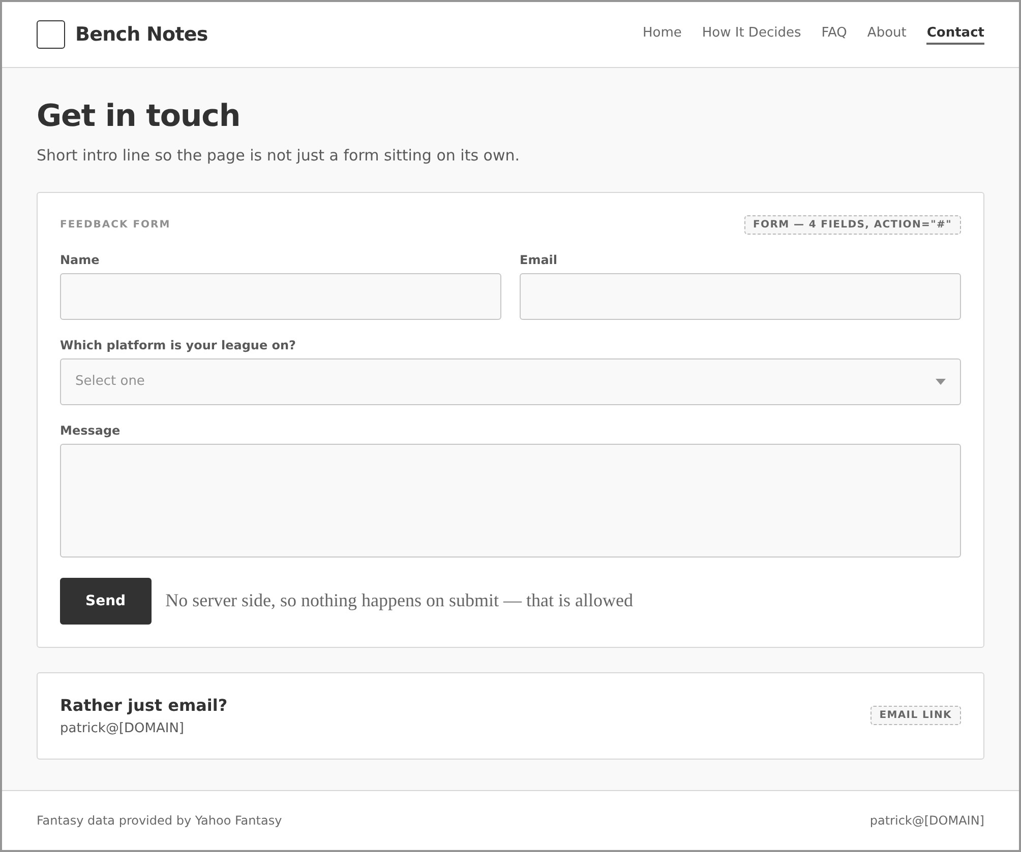

- List your project website's GitHub URL. (10 points)
https://github.com/phewitt036/cis300
The project site files (index.html, bench-notes.css, and the images folder) are in the cis300-site folder of that repository:
https://github.com/phewitt036/cis300/tree/main/cis300-site

- After doing several pages, has your sitemap changed? If so, revise your previous sitemap and insert it below: (10 points).
My sitemap has not changed from the five pages I listed on the planning and analysis sheet. Home is the landing page and the four content pages sit one level below it. The nav bar is identical on every page, so the hierarchy below shows entry order rather than the only path between pages. Here it is drawn out:
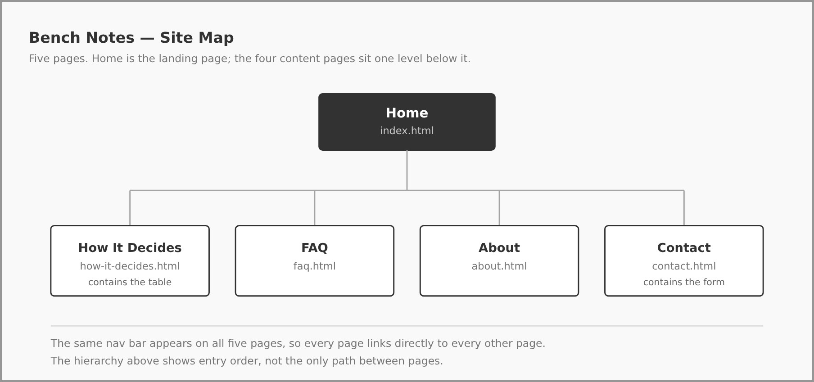

- Insert the latest wireframe below: (10 points)
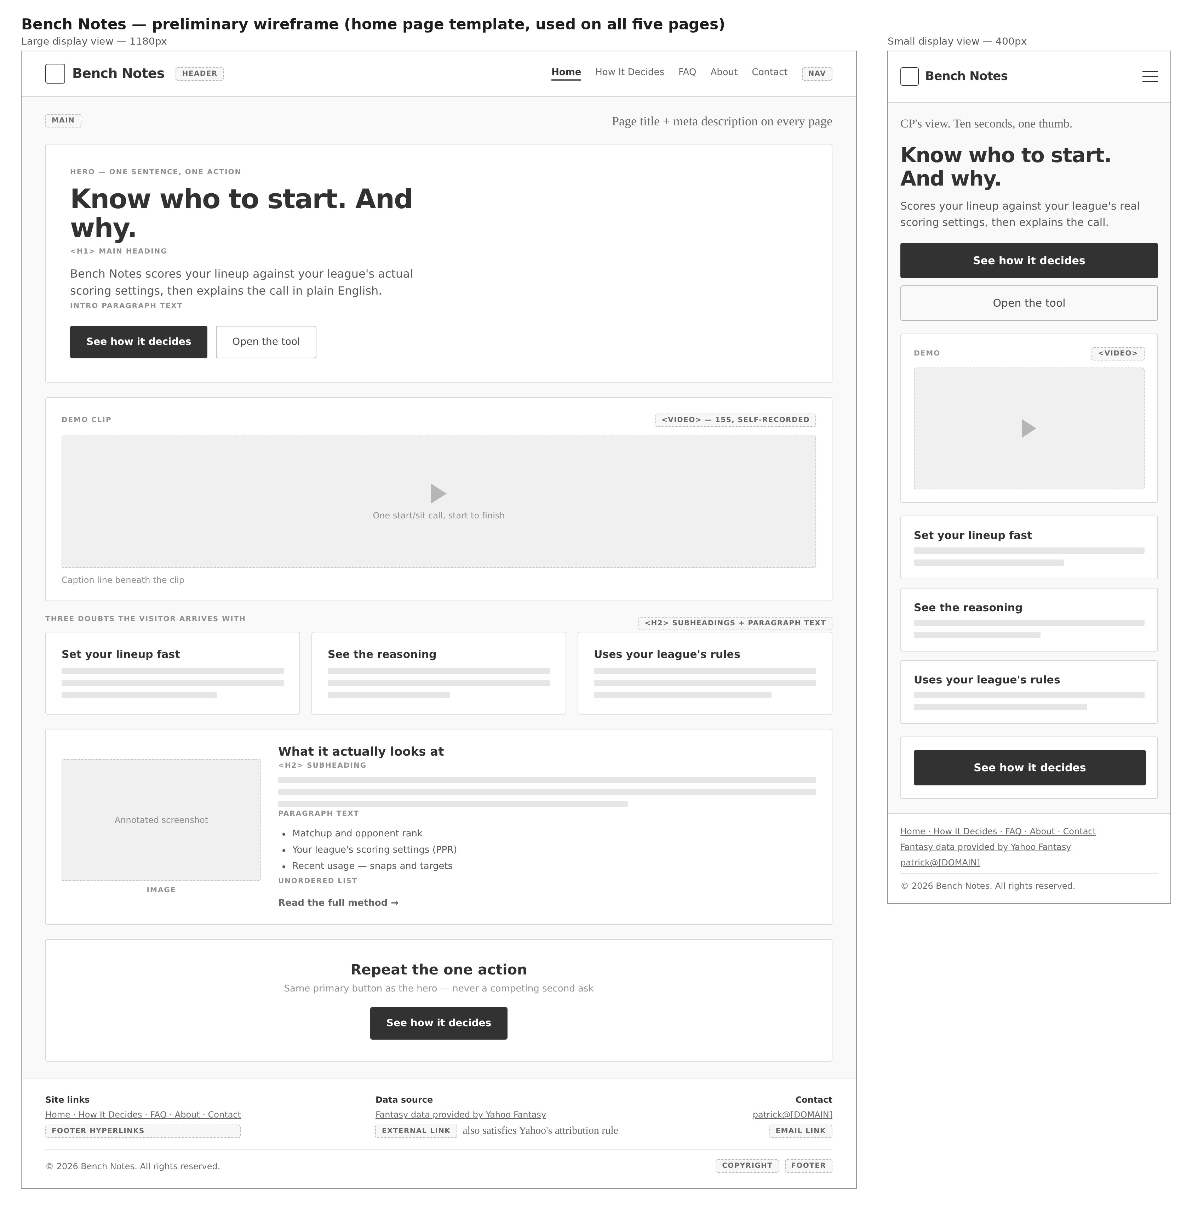

Web page browser view screenshot of Page #1 (15 points)
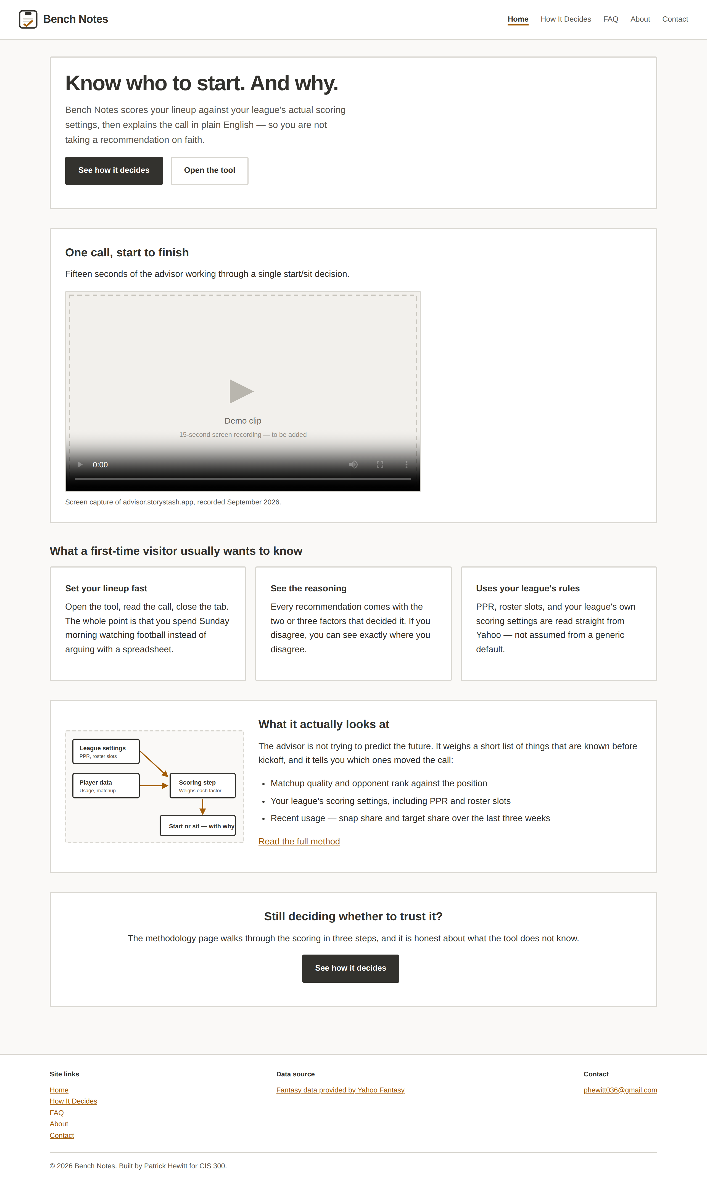
Screenshot of CSS file
Should include at least 5 selectors and 15 properties (15 points, 1 point for each)
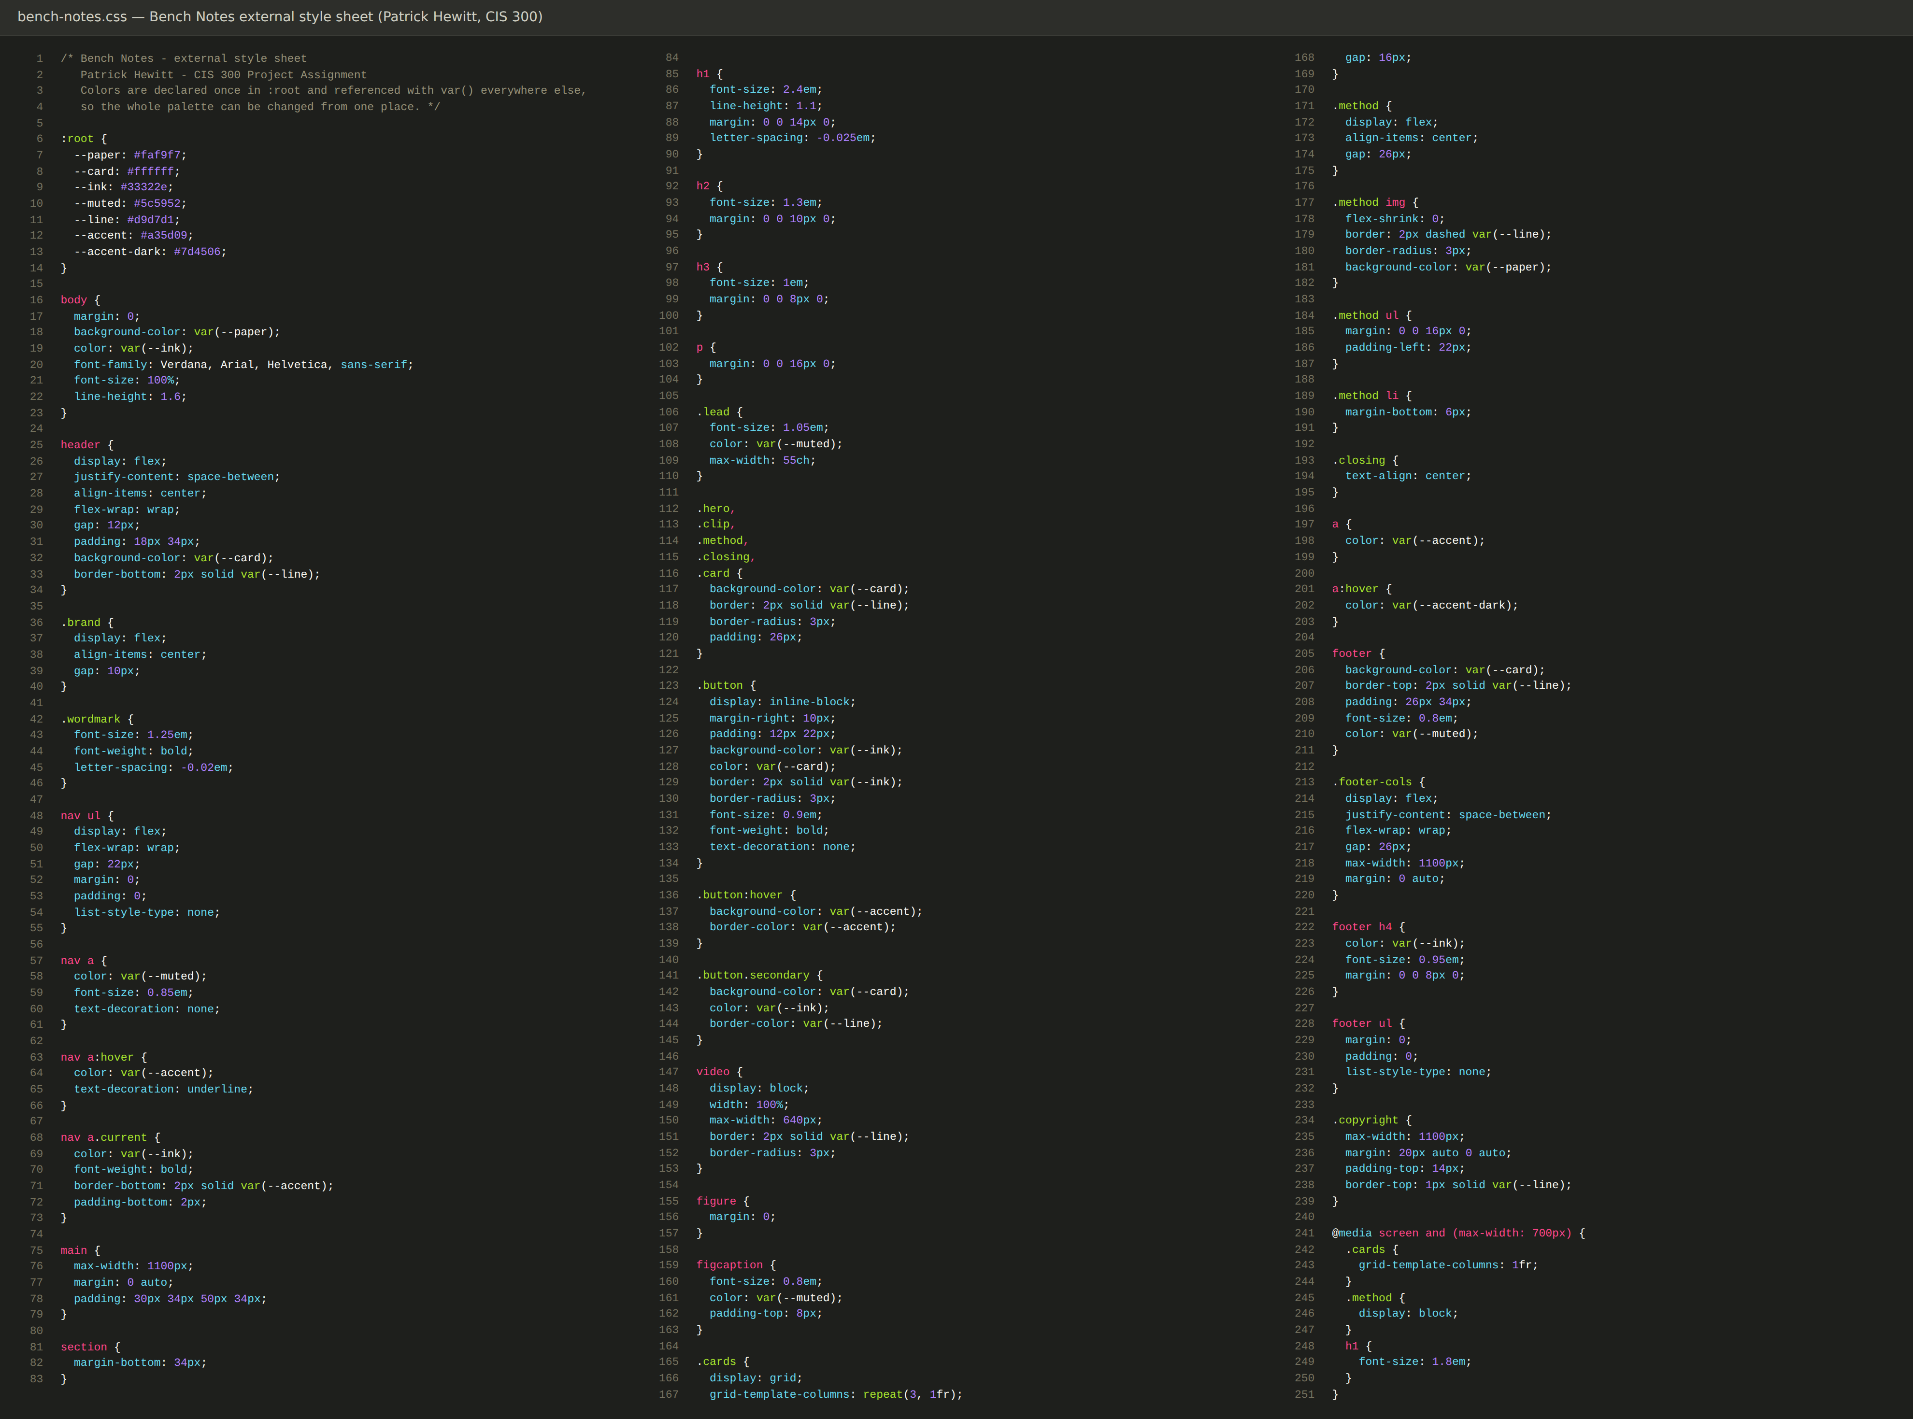
bench-notes.css contains 43 selectors and 126 declarations. The complete file is shown above.

